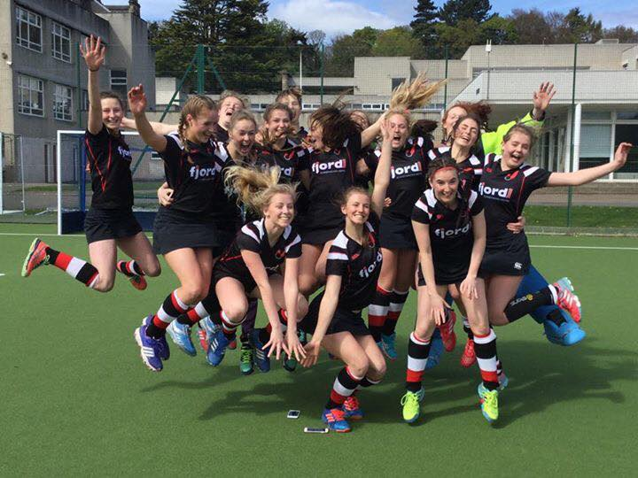

**WELCOME**

**FJORDHUS REIVERS HOCKEY CLUB**

 **SEASON 2023/24**



## Welcome to Fjordhus Reivers Hockey Club

We were proudly founded as a mixed hockey club in 2009. From that beginning we have grown and become an inclusive, family-orientated club, who aim to engage the whole of our community with sport.

With hockey programmes for under eights through to Masters, which cater for everyone from social players to internationalists, we are

The Scottish Borders hockey club for everyone.

Welcome to, or welcome back to Fjordhus Reivers Hockey Club!

It will be more than fantastic having you playing in our club colours in our 2023-2024 season

**THE BIG REDPRINT**

Our Fjordhus Reivers family places a lot of importance on these core values and this season we will be asking everyone to live by them, in order to help us achieve our vision of being a hockey club for everyone.

 

**Respect**

We show respect to everyone by treating them with courtesy, politeness and kindness.



**Inclusivity**

We will always be inclusive of all. We are one big family with an open door.

**Invested**

We will take ownership of all that is happening, get involved and help shape its future.



**Excellence**

We will aim for excellence and be ambitious about what we can achieve.

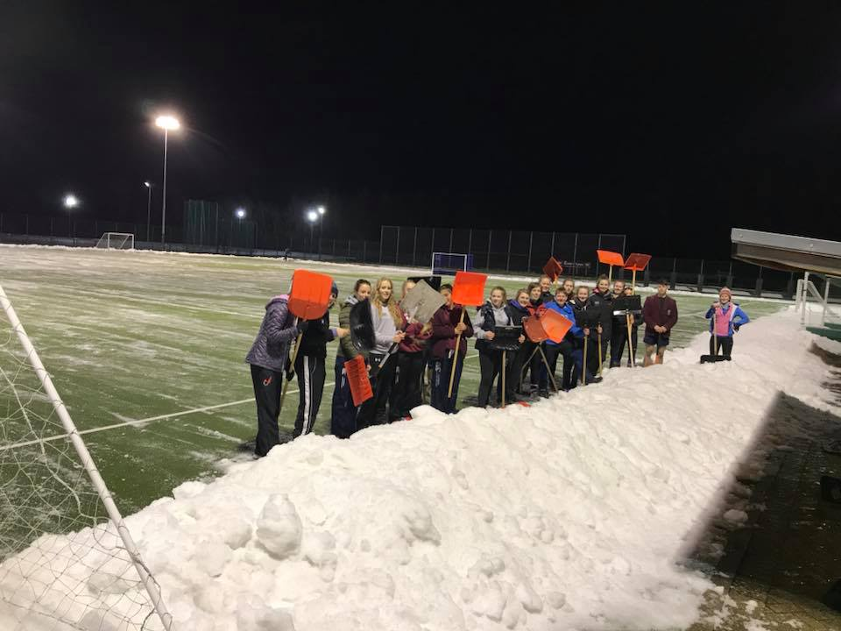

**What Hockey is on Offer This Season?**

We have outdoor and indoor training for all players, whatever your ability, age or aspirations, led by our team of paid coaches.

Throughout the season, all our outdoor and indoor teams also compete in competitive weekend leagues and cup competitions.

## What Hockey is on Offer This Season?

Training will be held at the following times and venues:

|  |
| --- |
| **Tuesday**  5.30pm – 7.00pm:- Ladies 5s and 6s (Starting 22nd August)  7pm – 8.30pm:- Men’s training (Starting 22nd August)  7.00pm – 8.30pm:- Ladies 1s training (Starting 15th August)  **Wednesday**  6.00pm – 7.00pm:- Performance (invitation only) (Starting 7th September)  7.00pm – 8.30pm:- Ladies 2s and 3s (starting 24th August)  **Thursday**  7.00pm – 8.30pm:- Ladies 1s training (Starting 17th August) |

## 

## C:\Users\jjack\Pictures\Fjordhus Photos\NdZ.PNG

## Club Hockey

### At every level our hockey is characterised by an aggressive intent to

go forward.

**Get excited!**



We play exciting attack-minded hockey.

In possession we always look to go forward.

Out of possession we look to win the ball back as quickly as possible, so we can go forward again.



## Where are we?

We play where the club was founded, **Tweedbank Outdoor Sports Complex**, although occasionally we overflow to **Selkirk High School.**

HOME PITCH ADDRESS:

Tweedbank Industrial Estate, Tweedbank, Galashiels TD1 3RS

Selkirk High School, Hillside Terrace, Selkirk TD7 4EW

 

## What Socialising is on Offer This Season?

Our social committee:

We need some volunteers!!

Be ready for…

Club Day

Christmas Social

Sports Day Club Dinner

Full calendar to come.

## Club Kit

**You will obviously also need some Fjordhus Reivers Robes!**

Our club are proud to wear **Fjordhus Reivers**

Our club kit is sourced for us by the fantastic ***BE uniforms*** and will be available for you to purchase, [**https://www.fjordhusreivershockey.co.uk/kit**](https://www.fjordhusreivershockey.co.uk/kit)

Before you order your kit, there is some information you need to know:

What personalisation can I get on my kit?

* Numbers on the back of playing kit are required for all those aged 14 years old and upwards.
* Numbers will be issued by the club. If you need a number, YOU MUST send a message on Teamo to be issued one. This is to prevent number duplication across club.
* Leisurewear can be personalised with initials on the sleeve if you so wish.

What items am I expected to own?

* ***Home top: For Fjordhus Reivers tshirt – black and away red shirt***
* Skorts/shorts – Black
* Socks- club Whacky socks which you can buy from your club coach

What items can I get online?

* All our leisure wear
* In store, initials and numbers can be applied to kit on the same day as purchase, however, for names players will have to wait

If you are unsure what kit to buy, please ask your coach

**Where is the online store?**

[**https://www.fjordhusreivershockey.co.uk/kit**](https://www.fjordhusreivershockey.co.uk/kit)

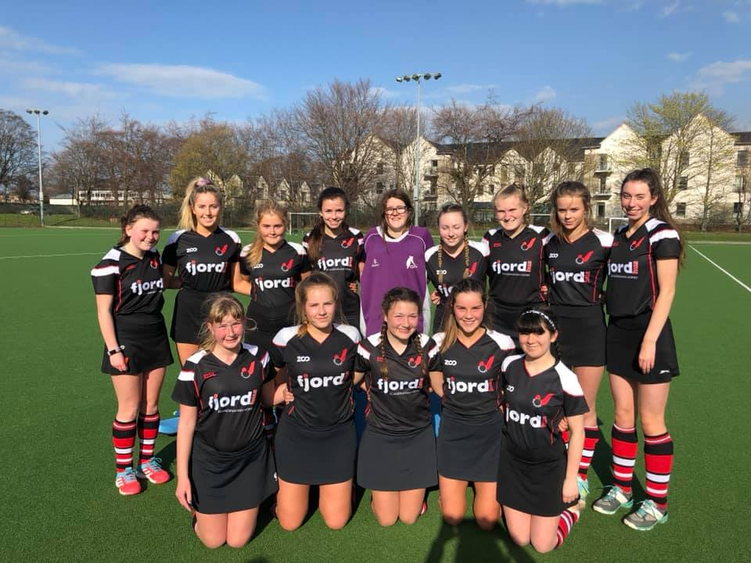

## Club Kit

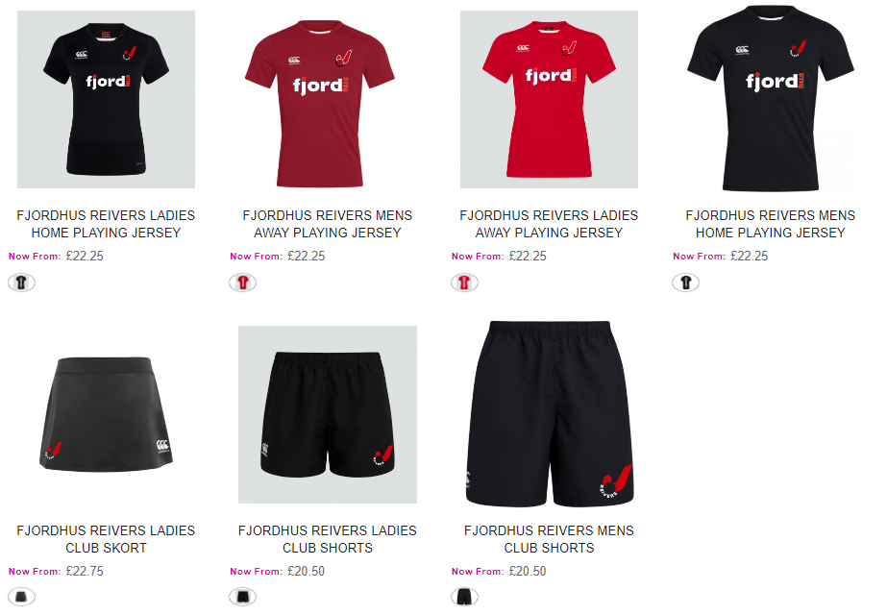

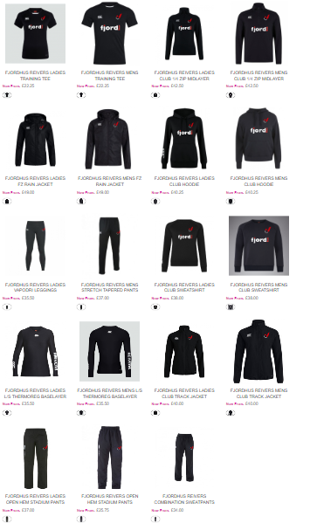

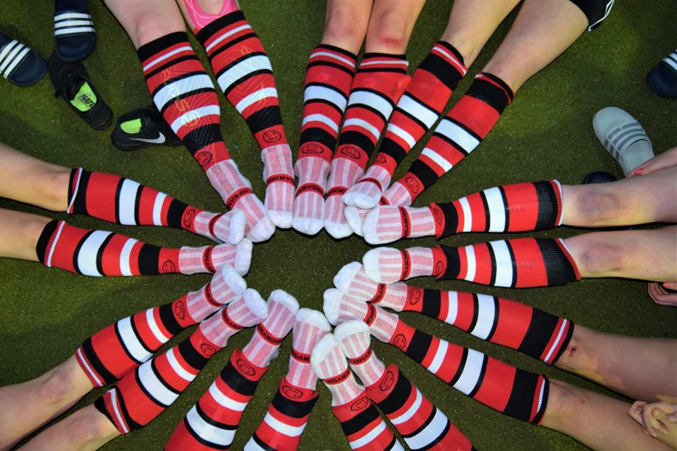

## Registration

Ready to sign up to a season with Fjordhus Reivers Hockey Club?

To **join or rejoin** our club you must complete registration through our TEAMO App



***Registration is key to ensure that you are covered by Insurance***

It is as easy as that!

The online form can be found here:

***Registration and subs are paid through our app TEAMO***.



Please do not hesitate to contact our club treasurer if you require to pay subs in a different format

Elena Lunn –

[Elena.lunn@fjordhus.com](mailto:Elena.lunn@fjordhus.com)



## Subscriptions

Outdoor subs determined by age as at 1st September:

Adults £200.00

Students/Unemployed £120.00

U16s and U18s £120.00

Social member £10.00

Indoor subs

* + Outdoor season FR members - £40

Subs are paid through our APP



Outdoor subscriptions are to be paid by

Indoor subscriptions to be paid by 30th November.

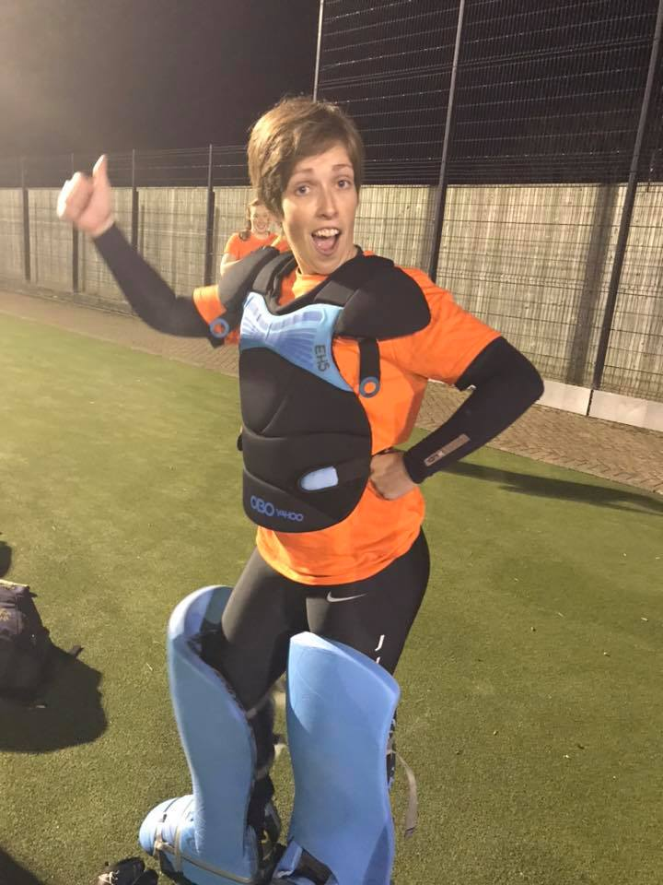

## Communication -

Web Site

The Fjordhus Reivers Hockey Club website can be found at:

<https://www.fjordhusreivershockey.co.uk/>

Facebook Group: For all players and parents

**Fjordhus Reivers Hockey Club-Players**

*This Facebook page is a valuable source for club news and all key information*.



**Social Media**

Follow us:

Twitter: @FjordhusReivers

Facebook Page: Fjordhus Reivers

Instagram: fjordhusreivershockeyclub

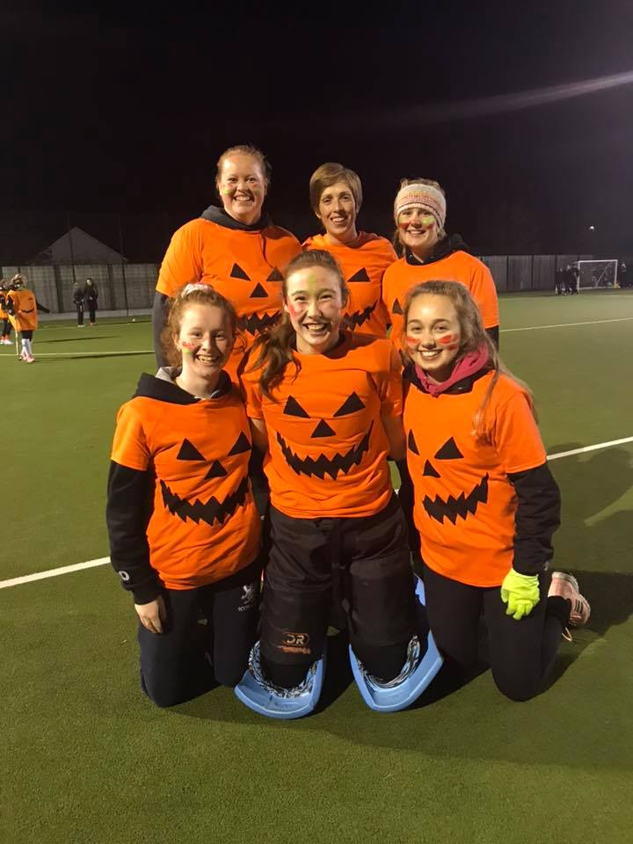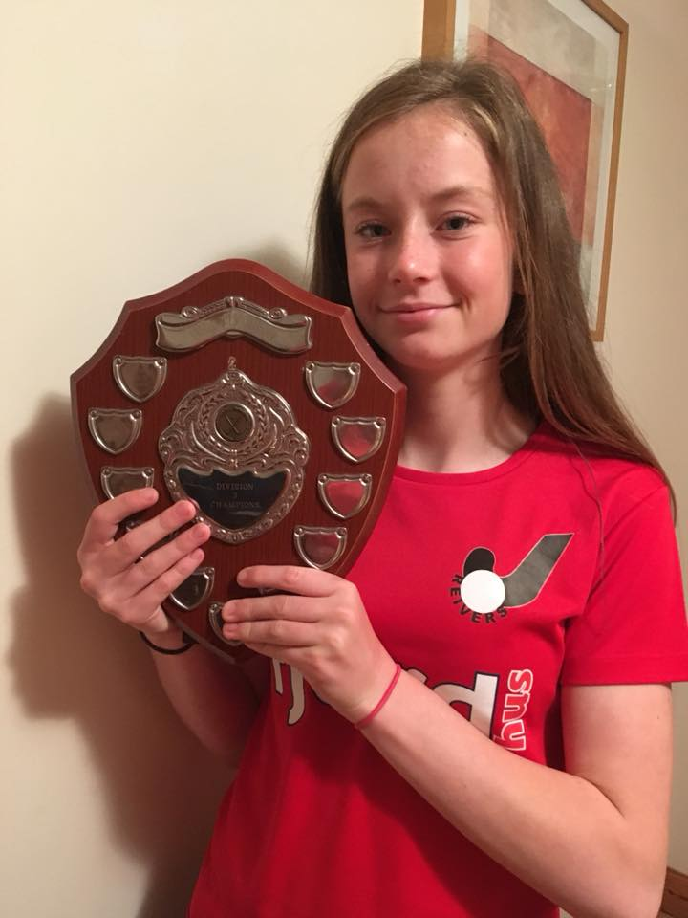

## Communication

Members Facebook Group

The club has a Members Facebook Group. This group serves as a forum, out of the public eye, for club discussions about anything from organising club events to organising umpires.

**Fjordhus Reivers Hockey Club-Players**

<https://www.facebook.com/groups/626403097500388/?epa=SEARCH_BOX>

A lot of the club organisation will be done via this group.

Therefore, can all players please join this community.



**Communication**

We will be managing our season through **email**, **WhatsApp group**, **Teamo**.

You will receive an invite from your team Manager.

Please reply promptly, it makes the organization of teams for the weekend much easier!

**To register to Teamo please email- helengracemontgomery@hotmail.co.uk**

# Codes of Conduct

## Player Code of Conduct

**A code designed to ensure we all know how to behave when representing the club both in club kit and beyond. When completing your registration form you will be asked to sign up to this code.** The following Codes of Conduct are based on the concept of fair play, defined by:

* + Respect for the rules of Field Hockey as governed by the FIH, England Hockey and as directed by Scottish Hockey;
  + Respect for the officials and their decisions, always;
  + Respect for all participants, including team-mates, coaches, opponents, parents, carers and spectators;
  + Equality in participation;
  + Maintaining positive self-control at all times.

**PLAYER CODE OF CONDUCT**

* + Make our sport fun and enjoyable, first and foremost;
  + Play fairly and encourage your team-mates;
  + Display good sportsmanship at all times;
  + Never threaten players or officials;
  + All players must play within the rules and respect officials and their instructions and decisions;
  + Never use foul or abusive language to either your team-mates, officials, spectators or opponents;
  + Respect the choices of all members;
  + As a representative of Fjordhus Reivers Hockey Club, you must behave well and in an appropriate manner at all times;
  + Always, regardless of the result, shake hands with your opponents at the end of the game and look them in the eye;
  + Police each other. Set an example for yourself and all to follow;
  + Pay any fees for training or events promptly;

## Player Code of Conduct

* + Do not use social media as a platform to be abusive to other members of the club, opponents or officials. This will not be tolerated;
  + Keep to agreed timings for training and competitions or inform their coach or team manager if they are going to be late;
  + Wear suitable kit for training and match sessions, as agreed with the coach/team manager;
  + Engage with what my coach tells me. Take ownership of your development;
  + Always maintain our club values;
  + Talk to someone I trust if I’m unhappy about anything at my club.
  + Substance use / abuse
    - All players must abide by the Scottish Hockey Anti-Doping Rules
    - All players must not use illegal substances whilst at club events or whilst representing the club
    - All players must not promote the use of illegal substances

Hockey is a great team sport to be involved in and your conduct is central to your enjoyment of the game. Particularly be aware of how your actions affect those of your team-mates and opposition.

Always strive to develop your skills and those of your team-mates and above all else, ‘lead, do not follow’ - play your part and do your best.

Please respect the history you carry with the badge and always strive for positive behaviours.

**Better, Together, Always.**

## Spectator Code of Conduct

In addition to our Player Code of Conduct we also have a Spectator Code of Conduct:

* + All spectators must respect players, coaches and officials and their decisions. The use of bad language or negative comments which may cause offence will not be tolerated. Spectators displaying these kinds of behaviours will be asked to leave the pitch and the Club reserves the right to ask the relevant player to leave the Club. This covers training sessions and matches and also applies to the use of Social Media;
  + Spectators should applaud good play on both teams;
  + Spectators should be role models congratulating opponents and making their players and coaches feel welcome;
  + Always maintain our club values.

**Safeguarding Policy**

**Fjordhus Reivers** values young people and vulnerable as being a vital part of the organisation and desires to see them grow, mature and be challenged in a healthy and safe environment.

The name of the child and wellbeing protection officer (CWPO) for Fjordhus Reivers is **Janet Jack**

**Purposes**

The purpose of **Fjordhus Reivers** programme is to offer young people a safe and welcoming learning environment where they can grow and learn.

**Aims**

To provide sport for young people to help them develop from childhood into adulthood

and to provide support for them**.**

To enable the young people to express themselves.

To assist young people in integrating into the community.

To help children/young people appreciate the diversity of their cultures.

***Each young person should be formally registered with Fjordhus Reivers.***

The information includes an information/consent form which their parent/guardian must complete. These forms have vital information about health and emergency contacts and will be kept securely and brought to each session

**Child Protection Representative**

Fjordhus Reivers has appointed a child protection representative, **JANET JACK**:

Phone:- 07766056937, email:- [jack788@btinternet.com](mailto:jack788@btinternet.com)

If anybody has any child safety concerns, they should discuss them with her.

Janet will take on the following responsibilities:

* Ensuring that the policy is being put into practice;
* Being the first point of contact for child protection issues;
* Keeping a record of any concerns expressed about child protection issues;
* Bringing any child protection concerns to the notice of the Management Committee

and contacting the Local Authority if appropriate;

* Ensuring that paid staff and volunteers are given appropriate supervision;
* Ensuring that everyone involved with the organisation is aware of the identity of the

Child Protection Representative.

## Grievance Procedure

The club believes that it is important that all members, coaches, administrators and parents associated with the club should, at all times, show respect and understanding for the safety and welfare of others. Therefore, members are encouraged to be open at all times and to share any concerns or complaints that they may have about any aspect of the club.

Grievance Procedure

Should any member have a grievance against the club or any of its members, there is a set procedure that should be followed.

If the matter cannot be resolved by reasonable conversation between those concerned then the following process should be followed:

* + The grievance should be detailed in writing to your Club Secretary Claire Townsend [townsendecosse@btinternet.com](mailto:townsendecosse@btinternet.com) and the club’s Child Wellbeing Protection Officer

Janet Jack [jack788@btinternet.com](mailto:jack788@btinternet.com) if required

* + They will then investigate the matter, seeking advice and if required ask for evidence from all parties involved.
  + A conclusion will be reached and all parties directly involved advised.

The club has always preferred any matters arising be settled amicably and without resort to formal process, however, this path is open to all.

The last few years brought enjoyable hockey to all Fjordhus Reivers members and with it much success and pleasure for the Club both on and off the field.

We look forward to the same in 2022 - 23

|  |  |  |
| --- | --- | --- |
| **Team** | **League** | **2021 - 22** |
| Ladies 1s | **National League 1**  **2022-23** | **2nd** |
| Ladies 2s | **East Division 1 – 2022-23** | **7th** |
| Ladies 3s | **East Division 1- 2022-23** | **Winners** |
| Ladies 4s | **East League 3 2022-23** | **-** |
| Ladies 5s | **East League 3** | **4th** |
| Ladies 6s | **East League 3** | **4th** |
| Men | **East League 2 2022-23** | **3rd** |
| U16 Performance | **East u16 League Premier** | **3rd** |
| U16 Div 1 | **East u16 League 1** | **3rd** |



# Club Officials

#### WELCOME

**Key Contacts**

For all club matters beyond the remit of your particular section please contact

Janet Jack – Head Coach

[Jack788@btinternet.com](mailto:Jack788@btinternet.com)

Ladies players should direct communications to:

**L1s** – Emma Pate [pate-89@hotmail.com](mailto:pate-89@hotmail.com)

**L2s** –Vicki Royan [vickiroyan@gmail.com](mailto:vickiroyan@gmail.com)

**L3s** – Elena Lunn [elena.lunn@fjordhus.com](mailto:elena.lunn@fjordhus.com)

**L4s** – Carolyn Allison [caly2111@gmail.com](mailto:caly2111@gmail.com)

**L6s** – Janet Jack [jack788@btinternet.com](mailto:jack788@btinternet.com)

**Men’s** players should direct communications to:

Ben Hortin: [benhortin@btopenworld.com](mailto:benhortin@btopenworld.com)

For all **payment** questions, please contact our treasurer to discuss:

**Treasurer**: Elena Lunn: [elena.lunn@fjordhus.com](mailto:elena.lunn@fjordhus.com)

For questions regarding registration, please contact our Club **Secretary**: Claire Townsend: townsendecosse@btinternet.com